LoginScenario_TestForMarineValidLogin_Instance1_03-Jul-2017_02-49-36_AM_Enter_user_credentials.png

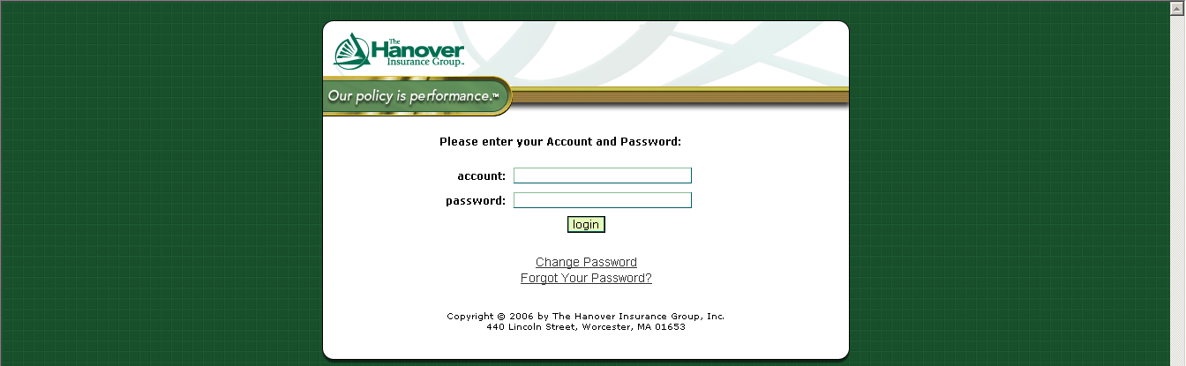

LoginScenario_TestForMarineValidLogin_Instance1_03-Jul-2017_02-49-38_AM_Login.png

